1.2 Imperial Measurement
FOM 10 September 14, 2020
Goal
- Providing referents for linear measurement
- Describing a strategy for taking linear measurement
- Solving problems that involve linear measurements using instruments
- Estimating linear measurements
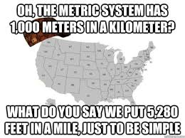
Vocabulary
- Imperial System

Imperial Table
1 foot (ft) = _________ inches
1 yard (yd) = ________ feet or ________ inches
1 mile (mi) = ________ yards or ________ feet
1 Inch = __________ cm
Examples
- How many inches in 3 ½ yards?

- How many miles are in 12 640 feet?

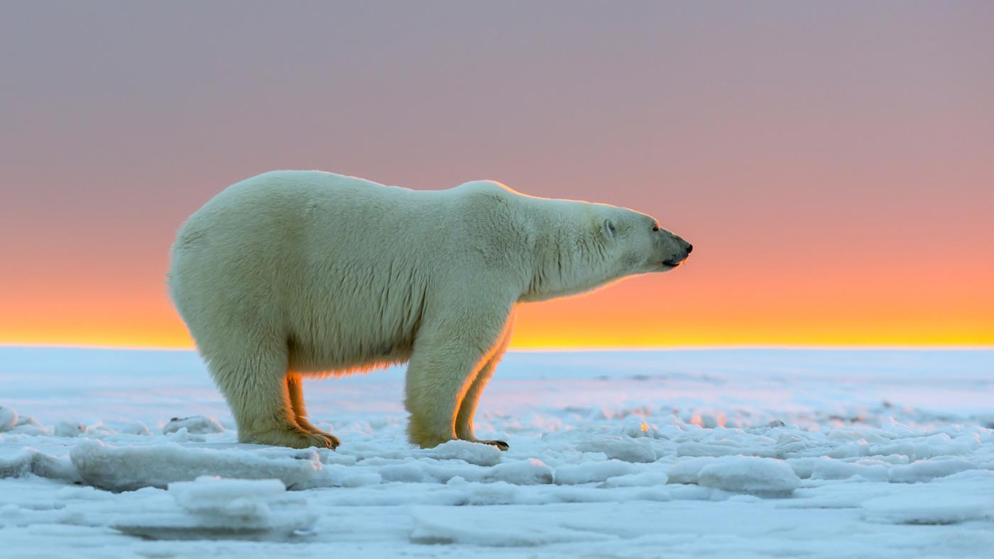
- This photograph shows a polar bear near Churchill, MB. The scale of the photograph is 1:35.

  - Calculate the height of the bears back to the nearest inch.
  - What is the length of the bear? State your answer in feet and whole inches.

- Carson wants to buy a 32” computer screen for his insane gaming habit. The size of a screen is measured diagonally. He is choosing between a 4:3 screen 4K television set, or a 16:9 HDTV. To help him decide, calculate she screen dimensions and the viewing area for each television. Which screen has a greater viewing area?

32
32

- Kate wants to make a drum, or qilaut, that resembles one used by a drum dancer in Iqaluit, NU. She has a circular frame, over which to stretch elk skin. Then, she will lash it into place along the frame with sinew. Kate uses 3 ½ inches of sinew for each inch of the frame.
  - Estimate the diameter of the drum frame in imperial units. The scale of the drum is 1:15. The plans Kate drew has the drum at 1 inch in diameter.
  - Approximately what length of sinew does Kate need to make the drum? State your answer in yards and inches

Page 29-35 #2, 6, 8, 11, 15, 17, 18

