1.3 Converting Between SI and Imperial Units
Goals
- Comparing SI and imperial units using referents
- Solving problems that involve conversions of linear measurements between SI and Imperial Units
- Using Mental Mathematics to confirm the reasonableness of a solution to a conversion problem.
Vocabulary
None
Unit Conversions

1 Inch= __________ cm
1 ft = __________ cm
1 yd = ___________ m
1 mm = __________ inches
1 cm = __________ inches
1 m = _________ yd
1 m = _________ ft
1 km = __________ mi
1 mi = __________ km

Examples
- Researchers at Harvard-Smithsonian Center for Astrophysics made an announcement in January, 2001. They stated that they had “frozen-light” by using super-cooled vapour to slow the speed of light waves to zero. The speed of light in a vacuum is defined at 299 792 458 m/s.
  - Estimate the speed of light in miles per second
  - Predict whether the actual speed of light is greater than your estimate. Justify your prediction.
  - Calculate the answer to the nearest mile per second and mile per hour

- Your class needs to lay mats on the gymnasium floor for a gymnastic meet. The gym measures 84’ by 50’. The scale drawing of one mat is shown and the scale is 1: 30.5. A classmate thinks 131 mats are needed. Do you agree? Explain.
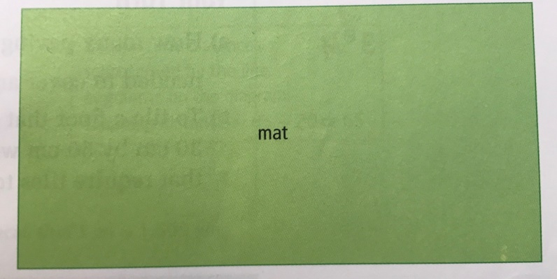

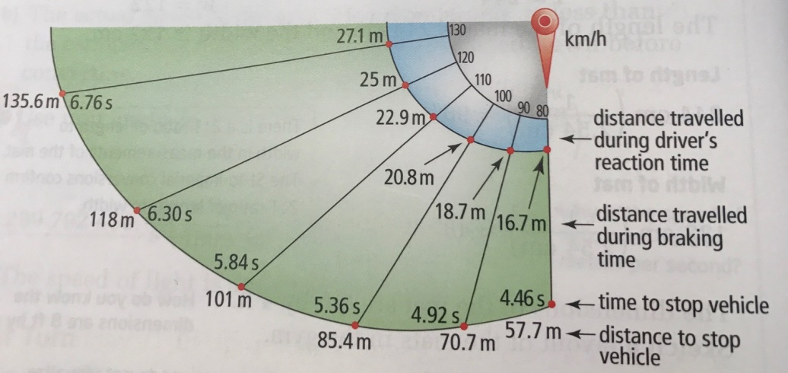
- The distance required to stop a moving vehicle is the sum of the distances travelled during the reaction time and the braking time. The diagram shows the theoretical stopping distance at various speeds.

  - What factors might affect the reaction time and braking distances?
  - If a vehicle is travelling 100 km/h, approximately what distance is travelled while the brakes are being applied?
  - Convert 55 mph into kilometers per hour. Which is the approximate stopping distance when a vehicle is travelling at this speed? Express your answers in feet.

Page 42-47 # 2, 3, 5, 10, 11, 12, 13, 18.

