3.2 The Sine and Cosine Ratios
Goals
- Using the Sine ratio to solve problems involving right triangles
- Solving problems the involve direct and indirect measurement
Vocabulary
Sine Ratio
Cosine Ratio
Primary Trigonometric Ratios
Formulas

Examples
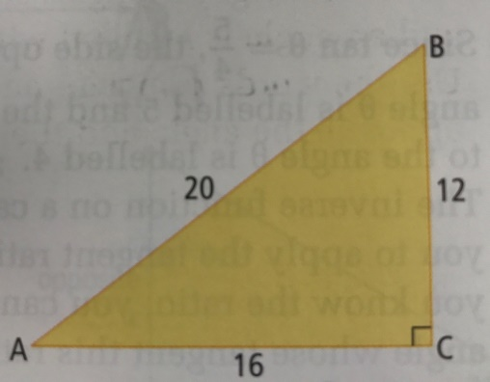
- Write each trigonometric ration
  - sin A
  - sin B
  - cos A
  - cos B

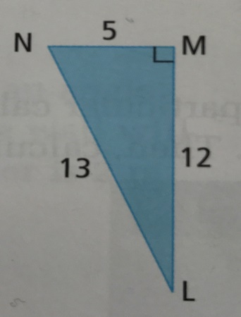
- Write each trigonometric ratio
  - sin L
  - cos N
  - cos L
  - sin N

- Evaluate each ratio to four decimal places
  - sin 42 ̊
  - cos 68 ̊

- Determine each angle to the nearest degree
  - sin θ = 0.6691
  - cos θ = 0.7225

- In the World Cup Downhill held at Panorama, the skiers raced 3514m down the mountain. If the vertical height of the course was 984m, determine the average angle of the ski course with the ground. Express your answer to the nearest tenth of a degree.

6. Sin or Cos example with the variable on the bottom……

Assignment: Page 120-123 #1, 2, 3, 6, 7, 8, 10, 12, 14, 15

