4.1 Square Roots and Cube Roots
Goals
- Determining the square root of a perfect square and explaining the process
- Determining the cube root of a perfect cube and explaining the process
- Solving problems involving square roots and cube roots
Vocabulary
- Perfect Square
- Square root
- Perfect Cube
- Cube Root
- Prime Factorization

Examples
- State whether each of the following is a perfect square, a perfect cube, both or neither.
  - 121
  - 729
  - 356

- The uranium that Saskatchewan produces in a year has a volume of about 512 m³. If this volume were made into a single cube, what would the dimensions be

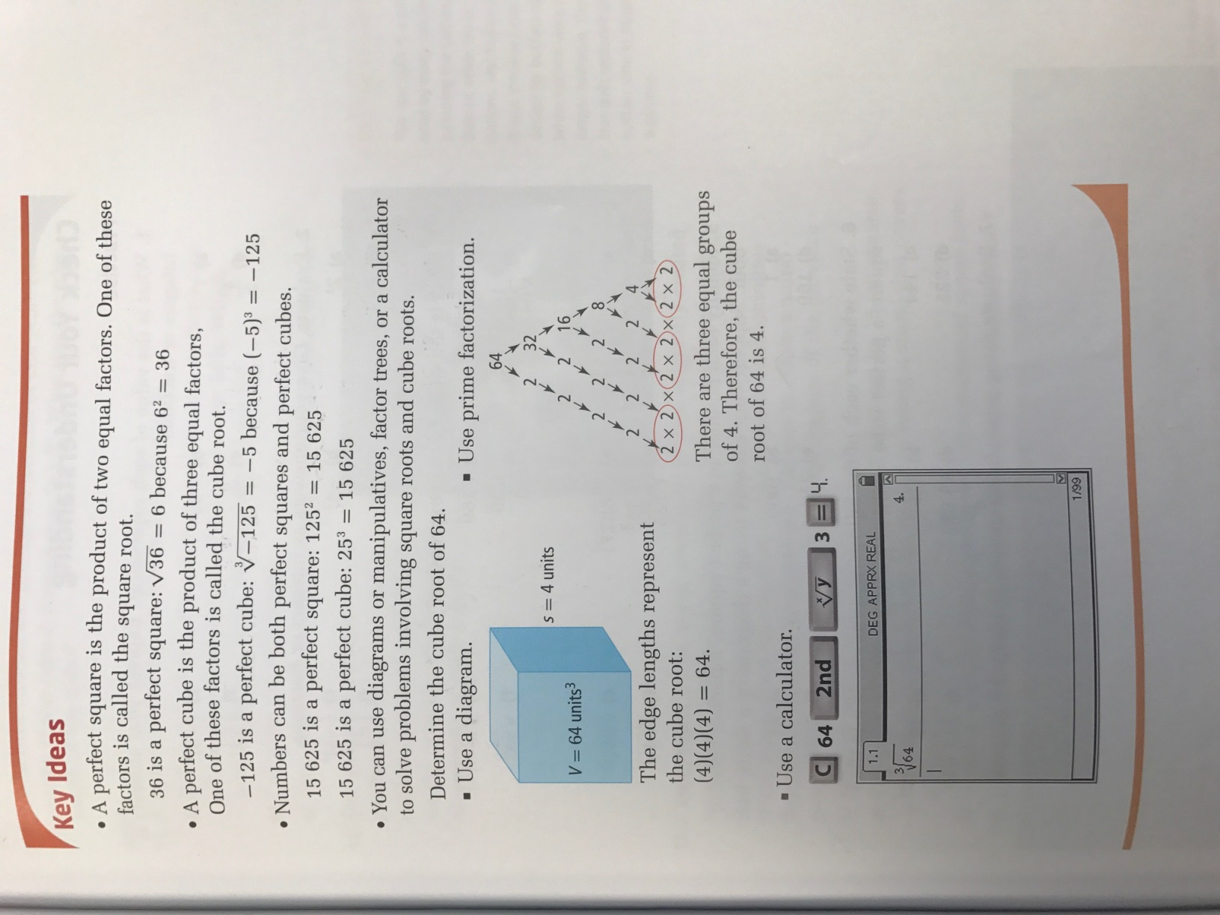

Page 158 # 1-5, 8-10, 13, 14, 16, 17

