**6.3 Domain and Range**

**Goals**

* Understanding the meaning of Domain and Range
* Expressing Domain and Range in a variety of ways

**Vocabulary**

1. Domain
2. Range

Notes

|  |  |
| --- | --- |
| Set Notation | What it Means |
|  |  |
|  |  |

Interval Notation:

**Examples**

1. 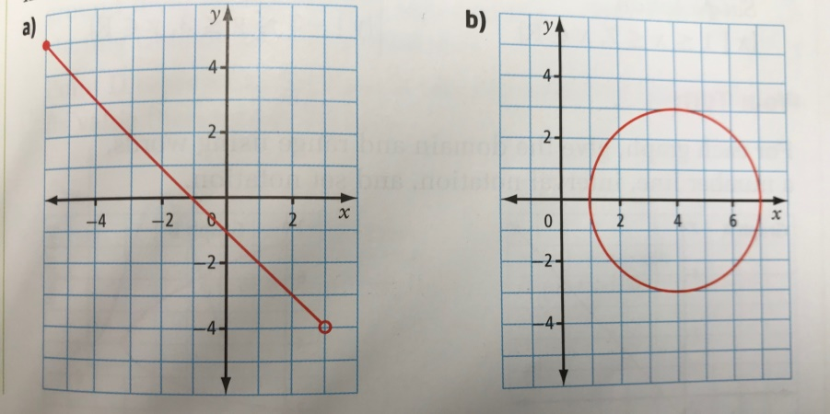For each graph, give the domain and range. Use words, a number line, interval notation and set notation.
2. The largest Ferris Wheel in the world is in China. The wheel has a maximum diameter of 193 m and a maximum height of 208 m. The graph shows the rider’s height relative to the ground for a 20 minute ride through one rotation.
   1. What are the values of points A, B, C and D, and what do they represent?
   2. 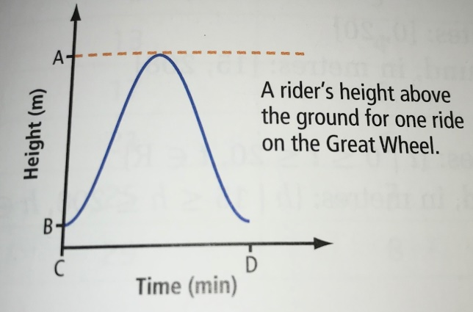What are the Domain and Range of the graph?
3. Mrs. Hrasko is marking time for some music by clapping on the first beat of every bar. The table shows the values and the set of ordered pairs show the relationship between the total number of beats and her total number of claps. Give the domain and range of the relation using words and a list.

|  |  |
| --- | --- |
| Number of Beats | Number of Claps |
| 1 | 1 |
| 5 | 2 |
| 9 | 3 |
| 13 | 4 |
| 17 | 5 |
| 21 | 6 |
| 25 | 7 |
| 29 | 8 |

Assignment Pg. 301-304 #1, 2(a-d), 3, 4a, 7, 9