**6.4 Functions**

**Goals**

* Sorting relations into functions And non functions
* Using notation specifically designed for functions
* Graphing linear functions

**Vocabulary**

1. Function
2. Function Notation
3. Vertical Line Test

**Notes**

Functions Vs. Non Functions

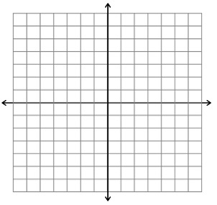The following are functions

|  |  |
| --- | --- |
| x | y |
|  |  |
|  |  |
|  |  |

|  |  |
| --- | --- |
| x | y |
|  |  |
|  |  |
|  |  |



_____________________________________________________________________________________

The following are non-functions

|  |  |
| --- | --- |
| x | y |
|  |  |
|  |  |
|  |  |

|  |  |
| --- | --- |
| x | y |
|  |  |
|  |  |
|  |  |



Examples

1. 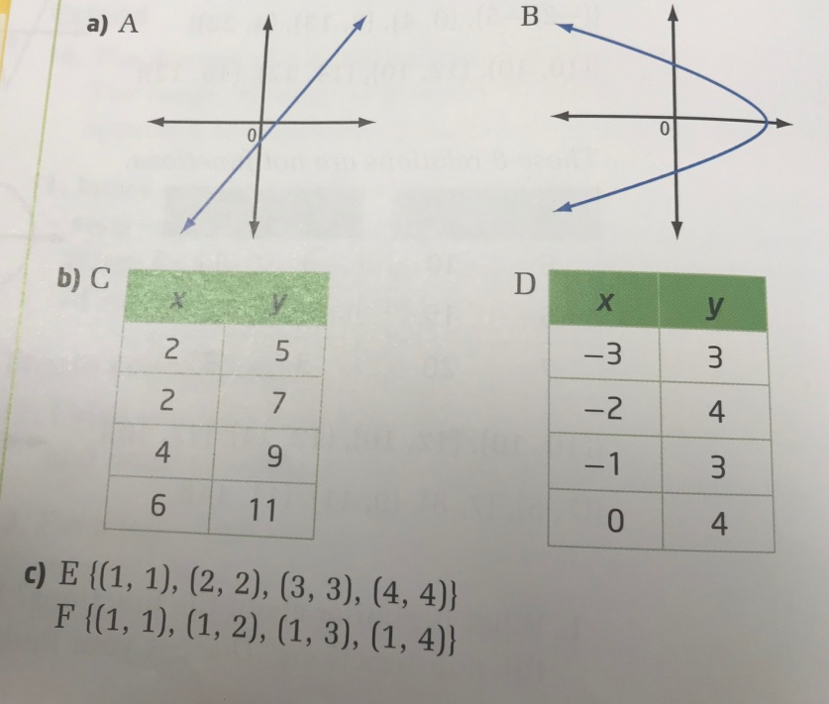 For each pair of relations, decide which relation is a function and which is not a function. Explain your choice.
2. The function F(C) = 1.8C + 32 is used to convert temperature in degrees celcius ( ̊C) to a temperature in degrees Fahrenheit ( ̊F).
   1. Determine F(25). Explain your answer
   2. Determine C so that F(C) = 100. Explain your answer.
3. Maggie has a cell phone plan for a monthly fee of $20 plus $0.15 for each text message to or from a number not on her list of favorites. Maggie’s monthly bill can be modelled by the relation C=0.15n + 20, where C is the total charge, in dollars, and n is the number of additional text messages.
   1. Write the relation in function notation.
   2. Make a table of values. Graph the function is Maggie sends up to four additional text messages.
   3. If Maggie’s cell phone bill for a certain month is $22.25, how many additional text message charges are there?

Page 311-314 # 1-5, 8, 10