**6.5 Slope**

**Goals**

* Determining the slope of a line
* Using slope to draw lines
* Understanding slope and rate of change
* Solving problems involving slope

**Vocabulary**

1. Slope

**Notes**

The slope of the line is equal to _____________________ or or

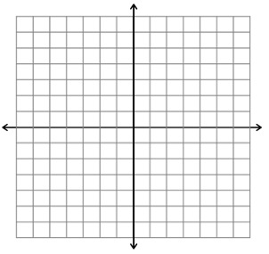

In a **positive** line, you move from ____________________________



For a **negative** line, you move from _________________________

When given the points of a line, you can use different techniques



Slope Formula Point Slope Formula

**Examples**

1. 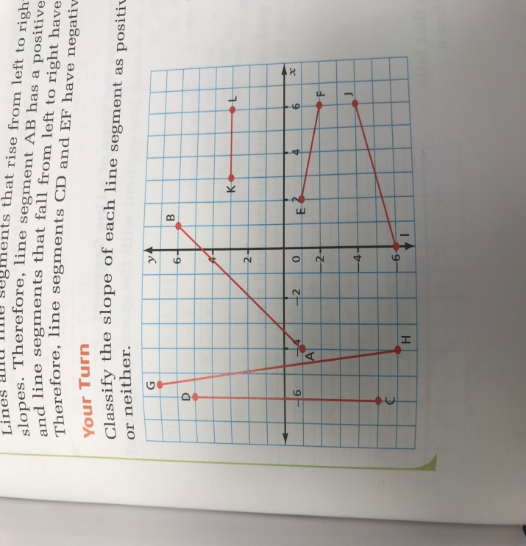 Classify the slope of each line segment as positive, negative or neither.
2. When discussing a roof truss, carpenters refer to span instead of width. They talk about pitch rather than the slope. Determine the pitch of the roof if the span of the entire truss is 48 ft and the height in the middle is 10 ft. Explain the meaning of your answer.
3. What is the slope of each line segment with the given end points.
   1. S (-3, 6) and T (5, 2)
   2. H (4, 3) and K (4, 8)
   3. M (-9, -7) and N (-1, -7)
4. The point (-3, 2) is on a line that has a slope of -3/4. List three other points on the graph
5. The Brentwood Regatta in Mill Bay, BC is the largest junior rowing regatta hosted by a single school in North America. The races are all 1500 m in length. The graph shows the approximate times at the 500 m mark and the 1000 m mark for one of the boy’s race.

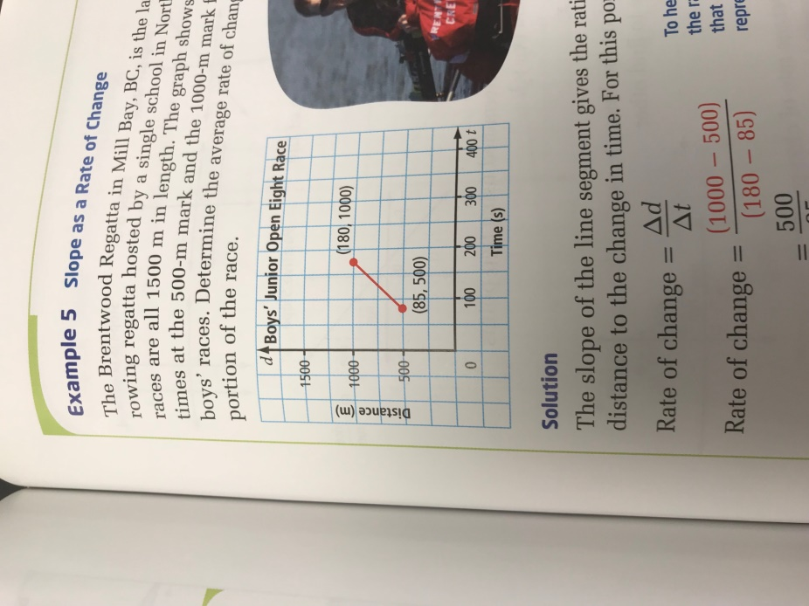

Page 325-329 #1, 2, 3, 4, 7, 10 AND Page 334 #14, 16