**7.2 General Form**

Goals

* Converting a linear equation to general form
* Using intercepts to graph a line
* Relating the intercepts of a graph to a situation
* Solving problems using equations in genereal form

Vocabulary

1. General Form
2. X-Intercept

Notes

The formula for General form is:

The formula for Slope-Intercept form is:

The difference is :

Examples

1. Rewrite the equations y = -2/3X + 6 in general form
2. For the linear equation 2x – 3y – 6 = 0,
   1. State the x intercept of a graph of the equation
   2. State the y intercept
   3. Use the intercepts to graph the line



1. Sketch the linear relation and identify the intercepts. Then state the Domain and Range
   1. Y - 3 = 0
   2. X + 4.5 = 0
   3. Y = 0
2. Carson has 66 GB of disk space left on his gaming PC to fill with the original Diablo game.
   1. Suppose the mod he wants to download uses 1.1 GB of disk space and an updated graphics package uses 4.4 GB. Write a linear equation that represents the number of mods, N, and Graphics packages, G, that Carson can download to his gaming PC
   2. Determine the N intercept of the graph of the linear equation. What does the N intercept represent
   3. If Carson downloads 16 mods, how many graphics packages does he have space for?

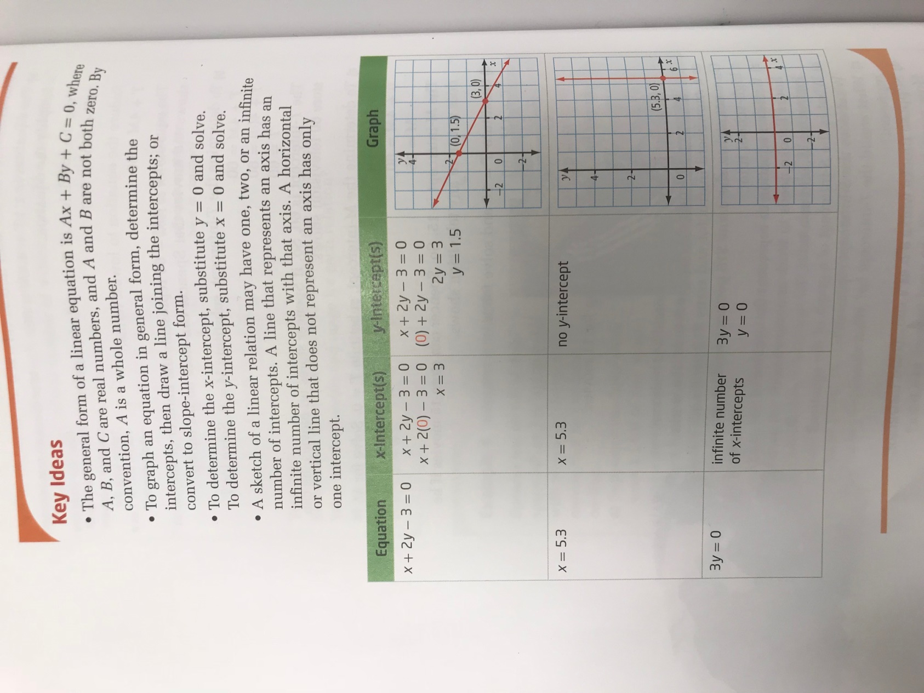

Page 365-369 #1-8, 13ab, 18, 19