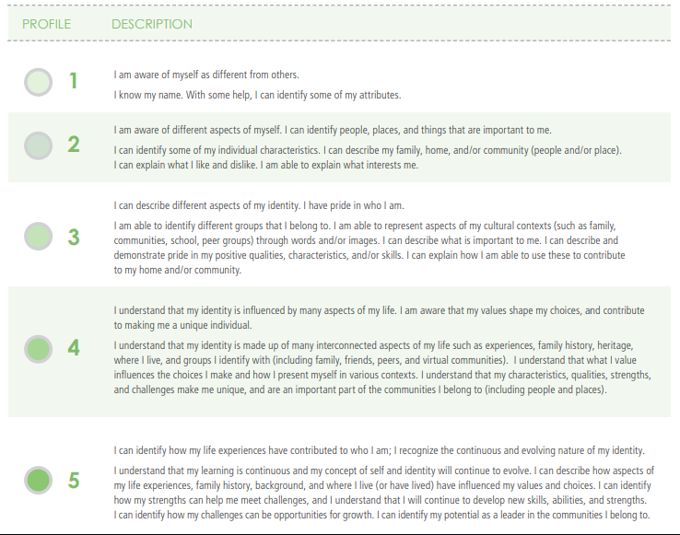
Positive Personal & Cultural Identity

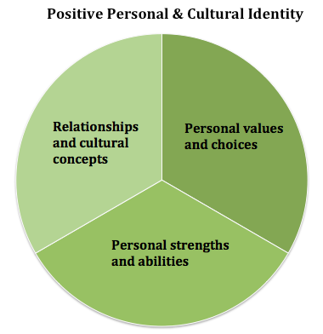

Name: (12C Sali) 2020
Date: Profile:  Evidence: | Date: Profile:  Evidence: | Date: Profile:  Evidence:

