3.1 The Tangent Ratio
Goals
- Expanding the relationships between similar triangles and the definition of a tangent ratio
- Identifying the hypotenuse, opposite, and adjacent sides for a given acute angle in a right triangle
- Develop strategies to solve right triangles
- Solving problems using the tangent ratio
Vocabulary
- Hypotenuse
- Opposite angle
- Adjacent Angle
- Tangent Ratio
Formula

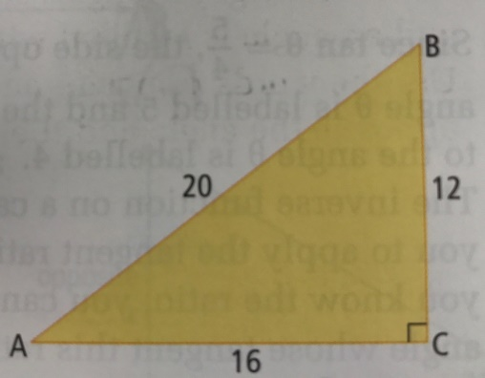
Examples
- Write each trigonometric ratio
  - tan A
  - tan B

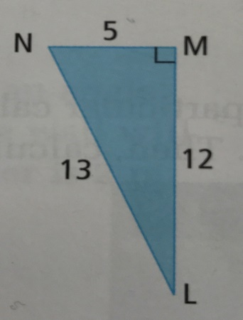
- Write each trigonometric ratio
  - tan L
  - tan N

- a. Calculate tan 25 to four decimal places
b. Draw a triangle to represent tan θ = 5/4. Calculate the angle θ to the tenth of a degree

- A surveyor wants to determine the width of a river for a proposed bridge. The distance the surveyor is from the proposed bridge site is 400m. The surveyor uses a theodolite to measure angles. The surveyor measures a 31 ̊ angle to the bridge site across the river. What is the width of the river to the nearest meter?

- A small boat is 95 m from the base of a light house that has a height of 36 meters above sea level. Calculate the angle of the boat to the top of the lighthouse. Express your answer to the nearest degree.

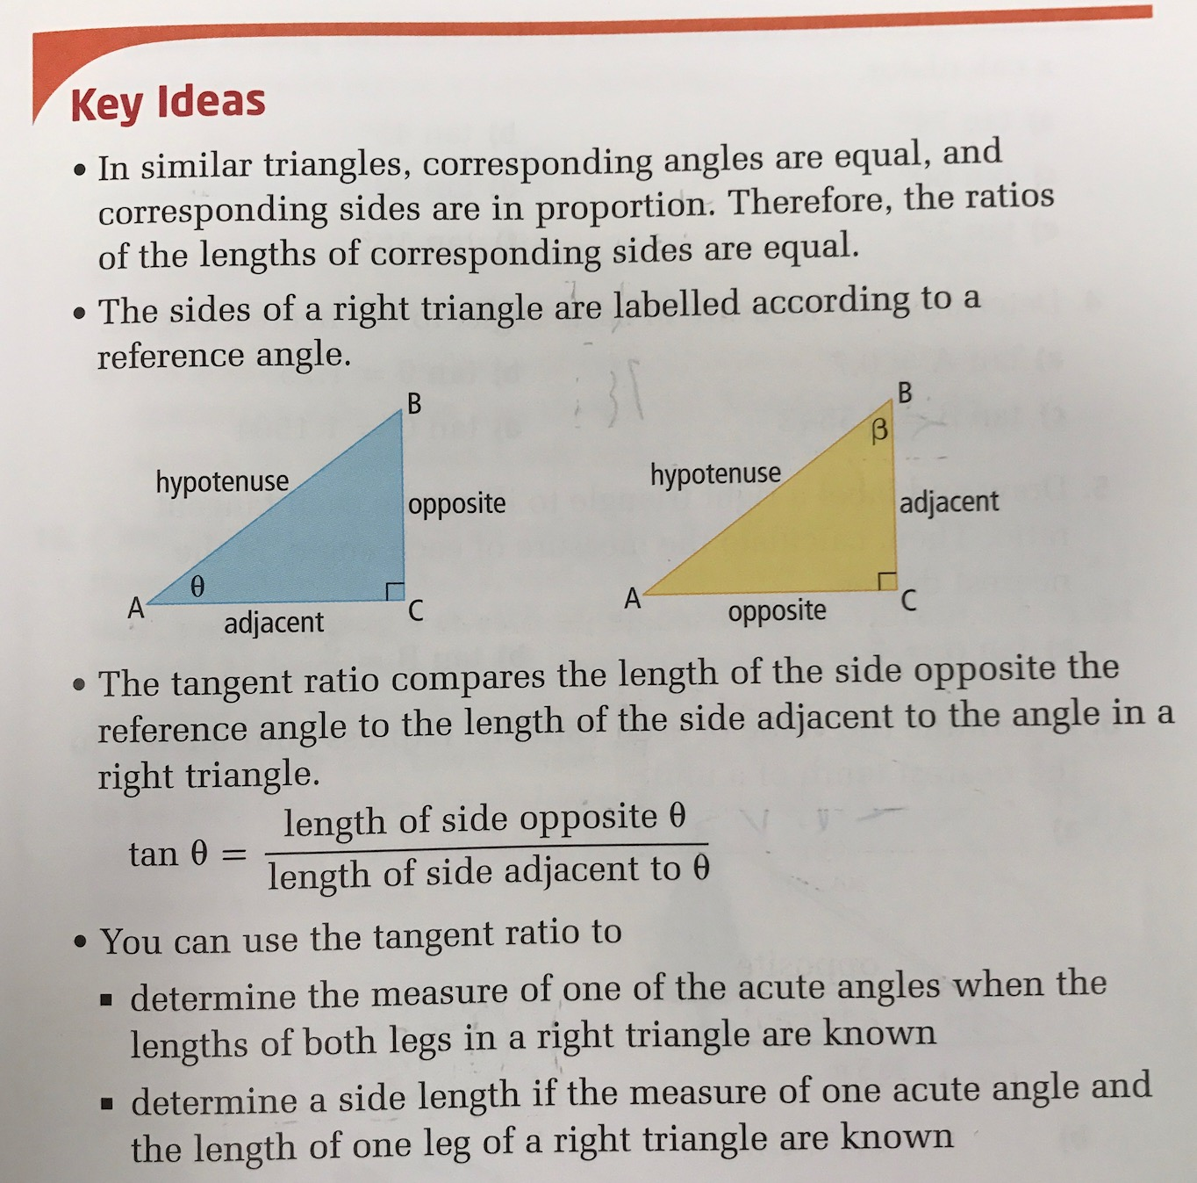

Page 107-113 # 1, 3, 4, 6, 8, 12, 14, 16

