Name: Date:
Math 10: Functions and Relations 6.2 Check in
Learning Target | Break down | Assessment | Overall
I can communicate relationships among data | I can describe a possible situation for a given graph and sketch a possible graph for a given situation
 | I can state the domain and range of a function in a contextualized situations and state whether it is a function or not
 | I can identify and represent linear relations in using graphs tables and equations
 | I can use rate of change to describe the graph of a linear function
 | I can use intercepts to describe the graph of a linear function

Learning Target: I can describe a possible situation for a given graph and sketch a possible graph for a given situation.
- The graph shows the speed of a windsurfer as a function of time.  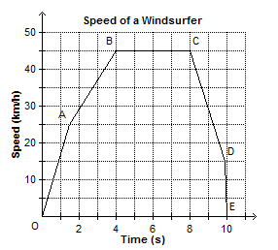  - How long did the windsurfer travel at a speed of 45 km/h? __________  - How long did the windsurfer’s ride last?  ________________  - Why are these points connected? | - This graph shows the speed of a hot air balloon, s, as a function of time, t.  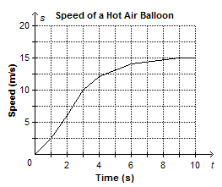  - Identify the independent variable: ________  - Identify the dependent variable: __________
- This graph represents a day trip from Vancouver to Hope, B.C. The distance between Vancouver and Hope is approximately 150 km.
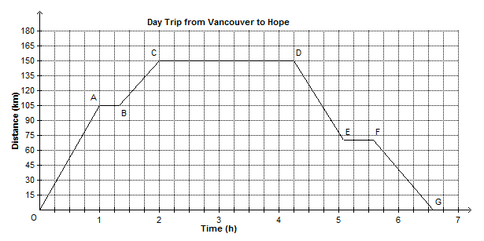

- Describe the journey for Segment O-A

- Describe the journey from segment D-E.

- Describe the journey from segment C-D.

- How long did the day trip take?

- What are the dependent and independent variables?

